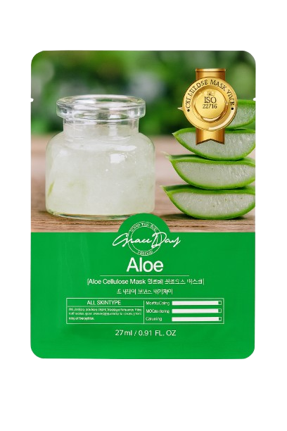
Name : Grace day sheet mask
Description : Grace Day sheet masks are Korean skincare products featuring a soft cellulose sheet infused with various essences (like Snail, Collagen, Hyaluronic Acid, Honey, Tea Tree, Rose, or Aloe) to deliver targeted hydration, nourishment, soothing, or anti-aging benefits, leaving skin soft, glowing, elastic, and revitalized for all skin types, often with a focus on natural ingredients and a gentle feel.
How to use :
Clean your face with face wash and pat dry.
Open the mask and gently place it on your face, aligning eyes, nose, and lips.
Leave it on for 15–20 minutes.
Remove the mask and gently massage the remaining serum into your skin.
Do not wash your face after.
Finish with moisturizer if needed.

